Caitlin Beirne and Olivianne James
Mrs. Candela
Advanced Web Design
November 19, 2015
Low-FODMAP Cooking: Cooking for a Cause
Introduction
Colors are something that draws our attention, it's pleasing. The Gastroenterological Society of Australia, or GESA, suggests people find fruits (low in FODMAPs) in a variety of colors to make the diet easier to concede to. A low-FODMAP diet removes lactose, gluten, fructose as well as many other ingredients because of the problems these create for people with certain diseases. This year we are competing in Michigan Council of Women in Technology’s web design competition with the theme “Food! Glorious Food!” We picked the low-FODMAP theme to bring attention to this relatively unknown solution to IBS. With the help of Caitlin’s mother (who is on this diet), and Dr. Lauren Van Dam, who is Caitlin’s mother’s nutritionist, we created a website based on the low-FODMAP diet. Through this website, we have illustrated recipes for potato soup, pizza, and cupcakes for those who are on the low-FODMAP diet, as well as an about the website page and an FAQ page.
Page One: Index
The first page of our website is our home page. We introduced the theme of MCWT’s web design competition as well as our twist on it. We introduced background to our innovated theme because we know it is unique and many may not know much about it. For our layout, we hit several snags in the road. We had created a cascading style sheet layout, but then we decided to try a responsive layout. Our website molds to each user’s specific screen resolution. We also chose purple, green, and white for our color scheme. The green and white came from many of the FODMAP cookbooks that Caitlin’s mom owns. We chose purple because it is the color of the support ribbon for people with IBS, the people who are most likely to do the diet. At our school, there is only one web design class. It merges both intro and advanced coders. Mrs. Candela is our teacher and in order to be a successful teacher to both classes, she spends her free time making videos for the advanced students to learn from. Since we have learned the basic codes, it’s easier for us than it would be for the intro students to learn from. We didn’t have it easy either though. We constantly had questions and the only way to get them answered would be to have a sticky-note conversation with Mrs. Candela. There is definitely a lot of sticky notes going back and forth. <insert sticky note joke> It’s like the world’s worst office email chain. Even though we hit a few snags, this experience has been once in a lifetime.
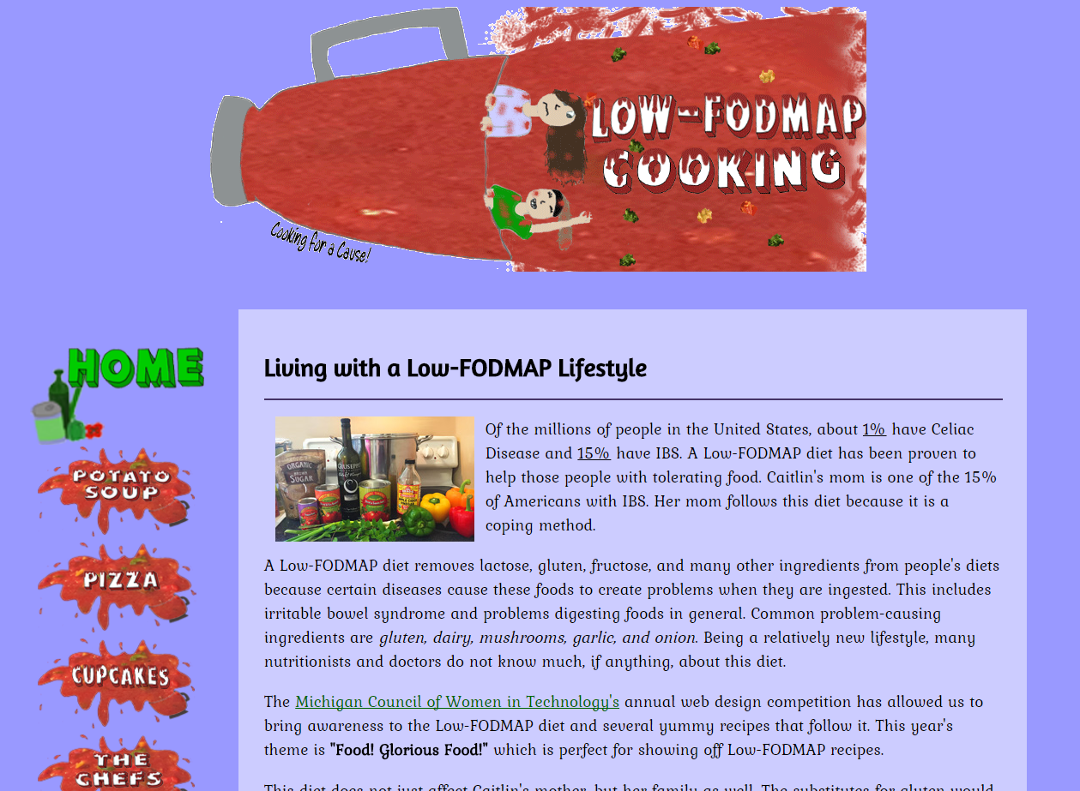
Page Two: Potato Soup
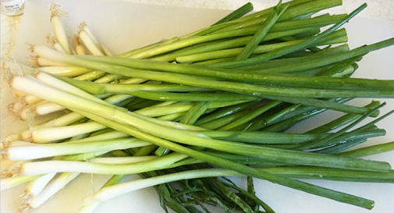
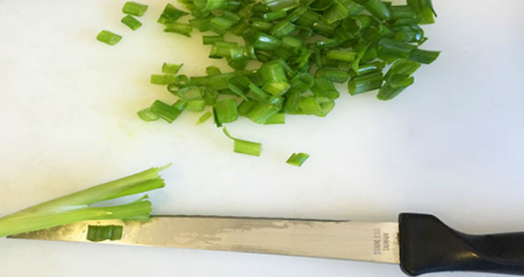
For our second page of the website we based it around potato soup. This page has a poll wrapped around the text, a recipe card for the potato soup and a step-by-step process of this recipe on a Prezi at the bottom. This poll was made using the website poll-maker. Throughout the creation of the website, we took many pictures and used Photoshop to edit them to our liking. Both of us have already taken Web Design so we have not had a Photoshop lesson in quite some time. Using Photoshop to create our animation and to edit our photos was very fun and not at all time consuming. Our favorite Photoshop edit would be the green onion pictures on step eight of the Prezi on this page. On these pictures we had to first brighten and sharpen it, as it was a little dark and blurry. Then it was saturated a tiny bit, as well as increase the lightness. We then used the spot healing tool to make the small green bits of green onion that were making the picture look messy disappear. We also used the spot healing tool to erase a tin part of the knife that was sticking out of the first picture.
Page Three: Pizza
Our third page was very meaty. To keep with the momentum we had of an interactive website, we added a Google Form for visitors to take. We also added a recipe card for our meat lover’s pizza and a Prezi. Our favorite code that we used on our website was the thumbnail code. One each recipe card, as well as a few documents on the last page, we added a code so that when you click on the image, it opens larger. We wanted the recipe cards to become larger so that visitors who liked our recipe could easily view it and could also print it out if they chose to keep it. We struggled to find a code that we liked. We tried to do a few Javascript codes, but we would get a different error every time. We realized we were better sticking with things we understood, and so we used this thumbnail code. In the end, it worked out pretty nice. It’s easy for visitors to view our recipe cards and they can easily print them out.
Page Four: Cupcakes
Our third item we prepared was cupcakes. We made low-FODMAP vanilla cupcakes with buttercream. We have a recipe card for the buttercream and a Prezi for the process. We also have a video on this page. Caitlin’s mom’s friend, Al Fox, is also participating in the low-FODMAP diet. He volunteered to be our guinea pig to teach a few simple cake decorating tips. We shot the video in several clips and cut down the excess footage in order to conserve our time and make sure we had a decent amount of time to put together our animation. We sped up the main pieces of the footage that we needed and added a few subtitles for each of the three lessons we taught. Since Caitlin has done a fair share of decorating, she taught Olivianne through these lessons as well. We wanted to be serious, but we also wanted to have fun. We started with teaching the basic swirl that goes on top of cupcakes by creating it on Al’s bald head. Next, we used another tip to create the perfect eyebrows for Al, since his real ones were fairly large hedges that he said needed no trimming. For our final lesson, we showed another use for tip 1M, the cupcake topping tip. It’s always fun to create swirls and patterns. Since we were using Al as our cupcake, we thought we would give him a mustache. Our video went as planned with a few bumps thanks to the lessons being too funny to hold the camera straight. Regardless of our problem, we really like our video and the rest of the page.
Page Five: The Chefs
The fifth page of our website includes a conclusion, some information about us, a table that presents all the technology classes we had, a citation list of all of the websites we used in the process of making this website, and a Prezi that explains the steps to take in order to create a website. Each element on this page is separated with a header on the very top of the element labeling what it is. On the very top of our website is an internal page anchor, that when clicked, is scrolled down to the part of the page you selected. It also has a cursor change over the internal page anchor. We placed the technology classes that we were in throughout high school in a large table. It is divided which classes Caitlin had, Olivianne had, and we both had. On the bottom we had inserted samples of the work we had completed in each class. Below the table is the citation section in a scroll box. We decided on using a scroll box instead of just listing them and having them take up a lot of space. With this scroll box we used the cursor change on the links. The citations have an unordered picture list with our favicon as the picture. With the creation of the website we used many resources, but the one we used the most would have to be W3Schools.com. This is our online textbook that has tutorials on HTML, CSS, and JavaScript. Caitlin and Olivianne ran into many problems in coding, and having this was a great resource to look back on and troubleshoot our problems.
Page Six: FAQ
Every good informative website ends with a frequently asked question page, so ours does too. The low-FODMAP diet is something that is not familiar to many people and we wanted to be clear as to the theme of our website. Using Caitlin’s mom’s nutritionist as a source of information, we were able to provide several key questions that go with the diet. We also added a section so we could add a picture of Dr. Lauren Van Dam, as well as add some information about her qualifications. It was on this page where we really started to have a time issue. Creating an extra page meant that we had to work on both our fifth and sixth pages in the same time frame. We also hit a snag with trying to find a code that we could use to make the documents that Dr. Lauren Van Dam gave us about the diet. We were unable to find one that would work through the school proxy. We ended up using the thumbnail code from the recipe cards and decided that visitors could then print the pictures larger if need be. Overall, we managed to complete our website and finish on time.
NETS
The most important of the six ISTE Student Standards would be communication and collaboration. In the web design contest you can choose to create the website yourself or with a partner. We both decided on partnering up on this to share our create ideas and split the workload between ourselves. We both felt that we worked very well together and even improved our friendship. If one was having a problem, the other would be right there and would always try to problem solve with the other. When there was not enough time at school to finish, they would get together after school to work on it. This website was a joint effort and we are both glad to have collaborated with each other to create it. In life you will have to be able to work with people, whether it be in the workforce or at school. With this skill that we improved in the making of this website we can better our skills and performance outside of school. Creativity and innovation is also an important ISTE Standard. Without creativity, contests revolving around a specific theme can produce multiple repeats. We used creativity to come up with a unique twist to the food theme that no one else was likely to do. We decided to base our website off of Caitlin’s mom’s low-FODMAP diet. We created this website to incorporate a diet that people do not know much about. It brings awareness to an issue that another country is far more advanced in than we are here in the United States.
Conclusion
Both of us were very honored to be given the chance to compete in the MCWT Web Design Contest. These past few months have been very hectic, but also very rewarding in the end. For Olivianne, the part that she enjoyed the most about the web design contest was drawing and animating the animation, as well as editing the pictures. Olivianne enjoys art and drawing, as well as being created. Making the animation look neat and fluid and saturating, spot healing and cropping the photos were the best part of this website for her. For Caitlin, the element that she liked the most was the navigation. Caitlin loved creating the magnification effect and also designing the splatter using a picture behind the actual drawing. Olivianne’s strength would be Photoshop. A weakness of Olivianne’s would be procrastination. Caitlin’s strength is her dedication and time-management skills. Caitlin is a very schedule oriented and an organized person. She always has a plan and follows through on it, and has it done in a very timely manner. A weakness of hers would be stubbornness. She would choose something and it would be very hard to budge and get her to change it. If we could go back and change a part of our website, we would change some of our animation and the work samples portion. For the animation we would have cleaned it up a bit and also change the drawn faces to actual pictures of our face. For the work samples portion we would have had it open in a separate window and display all the pictures bigger, but for some reason we could not get that code to work before the deadline. We can say with certainty that we would keep most of the elements on the page the same. This contest has improved a lot of our skills. We have improved communication skills, coding, editing, problem solving and time management skills. Working together has helped us communicate better with each other and compete tasks collaboratively. We also learned new codes and implementing them into a website. Photoshopping all of our pictures and animation has significantly improved our editing skills as well. Problem solving was a massive part of this process, because many problems have come up during the creation of our website. Fixing these problems has improved our problem solving abilities. Finally time management was also a big part of the website, because of the limited amount of time we had to complete these tasks. We had only about an hour in class each day, for five days a week. We had to manage the time we were given wisely to finish all the tasks. The skills we have used are a part of not only technology, but with life in general. Thank you Michigan Council of Women in Technology, for this opportunity to improve in not only technology, but improve as a well rounded person as well!

