Caitlin Beirne
December 1, 2015
2nd hour
Career Field Experience
A New Experience
Elbert Hubbard once said, “One machine can do the work of fifty ordinary men. No machine can do the work of one extraordinary man”. This quote relates to my Career Field Experience in many ways. Students can learn to build websites from online resources, but it is much more beneficial to learn from a teacher. Computers can also construct websites, but it only takes one outside-of-the-box student to create a masterful site. In my experience, I was required to student-teach the web design course at Lakeview High School while trying to decide if I wanted to go into teaching or the web design industry. Career Field Experience is a unique class because it gave me the skills I needed to do the job I may want to do in the future. For the last thirteen weeks, I have taught several lessons and helped my class build multiple websites. As I reflect on my experience from this trimester, I will outline three important skills employers look for: communication, computer/technical literacy, and planning/organization.
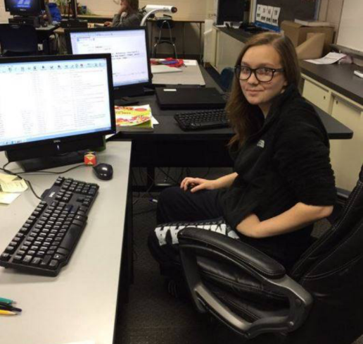
Throughout my experience at Lakeview High School, communication skills have been an important part toward my success. Before going to Lakeview, I knew I was a relatively shy person. Presentations and public speaking have always been my biggest fears at school. On day one of my experience, I was extremely nervous. I had never been to Lakeview and I did not know many people who went there. It took me about two weeks before I felt comfortable enough to make suggestions to the students. When the time came for me to teach my first lesson, I returned to my old, nervous habits. But by the time my second lesson came around, I had regained some of my communication skills and was able to present a decent lesson. The last half of my experience was a lot easier. I had gotten to know several students and was quite comfortable making suggestions. Communication skills became an important part of my job because I had to listen to what the students needed help with. Since no one in the class was a repeat, everything was a new topic/term. Sometimes it was hard to understand what they would ask for, but it became easier to communicate with them as I began to understand the way they were thinking things through. In the end, I had four students who were completely comfortable asking me for suggestions and I was fast to give it to them.
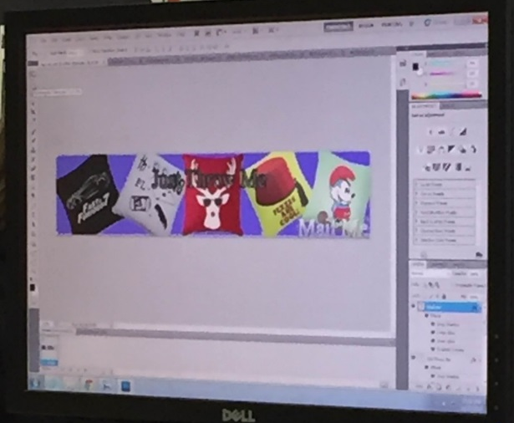
Another huge part of my Career Field Experience was my technical literacy. As the world continues to enhance technology, employers are also looking for employees with extensive computer literacy. In my experience, technical literacy is even more important because it is the subject matter at hand. Basic computer skills are so necessary to be able to teach in this field. I learned new ways to work in several applications as well as new applications in their entirety. But I went in with basic knowledge of Notepad ++ and Adobe Photoshop. During my experience, I was able to learn Adobe Fireworks as well. Although my supervisor, Mr. Spano, teaches differently than I’m used to, I was still able to comprehend their material and be of assistance to my students. I was quick to learn his coding style because of my previous knowledge of the software and codes. Lakeview also had an older version of Photoshop than I was used to working with so the location of certain edits was different as well as the overall techniques available to choose from. Since I had some basic knowledge of Photoshop, I was able to help with basic edits and how-to questions. Computer literacy has to be the most important skill that an employer in my field would be looking for.
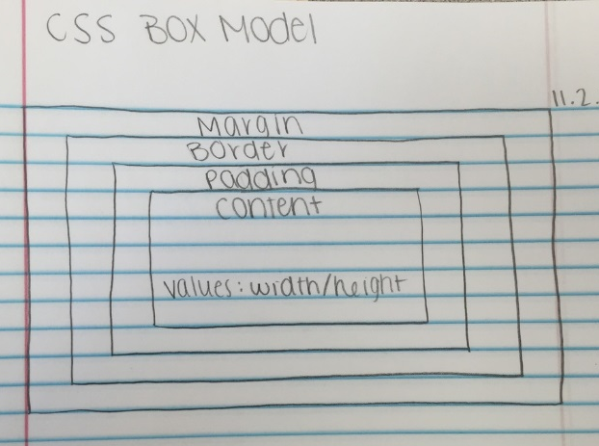
Additionally, planning and organizational skills are key to my experience. There is so much planning involved in the creation process of a website. From creating a bubbl.us for idea organization, to creating a site map to incorporate the box model for the layout. Organization is also key because certain codes will not work if you don’t have your files organized. Images need an image folder for the codes to work. My biggest pet peeve at Lakeview was the lack of organizational skills some students had. Files would be improperly named, folders were not where they should be, and some didn’t have necessary folders at all. Even though we stressed the importance of organization, it was not always followed. Employers look for planning and organization skills in order to determine the type of employee you are. If you have a large work load, you need to be able to plan accordingly in order to accomplish it all. Employers have to maintain a professional work environment and if you are disorganized, it affects the workplace atmosphere.
Career Field Experience has been an opportunity of a lifetime. I have gained more people skills and have more of an idea of the road I should take in the future. I came into the class not knowing if I should be a teacher or go into the industry, but I think I may want to go into the industry. I will never forget a suggestion I gave one student for her inspiration website. I had noticed most people were naming their sites “My Inspiration”, but I had seen that her inspirations were all celebrities. I suggested she name her site “Launching Skylar” since the stars had to launch their careers and her name was Skylar. She absolutely loved my idea. I would recommend this experience to a friend because it really is an experience of a lifetime. I could’ve wasted thousands of dollars only to find out I wanted to go into the web design industry rather than teaching it. It could work this way with anyone who isn’t sure what they want to do after high school. It’s also a good class for someone who knows what they want to do and who wants to get a head start with making connections in the field they want to go into. Career Field Experience is definitely worth taking and I am extremely happy that I had the opportunity to take it.

